**Project Report**

**On**

**“Student Management System”**



As partial fulfillment for the degree of

**Bachelor of Computer Application**

**At**

**K.S.K.V. Kachchh University,**

Bhuj.

(March - 2021)

**Submitted by:**

[ Dharmanshu Agravat (18BCA001)

Devarsh Antani (18BCA002 )

Mayank Rathod (18BCA040 ) ]

Dhiraj Solanki Mr. Archit A. Vohra Mr. Chintan P. Morabia

Project Guide I/c. Principal Director

**SANSKAR INSTITUTE OF MANAGEMENT & INFORMATION TECHNOLOGY**



**CERTIFICATE**

This is to certify that the project entitled “Student Management System” is a bonafide work carried out by Dharmanshu Agravat (18BCA001), Devarsh Antani (18BCA002), Mayank Rathod (18BCA040) for the degree of Bachelor of Computer Application at **Sanskar Institute of Management & Information Technology, Bhuj, Gujarat**.

To the best of our knowledge and belief, this work embodies the work of candidates themselves, has duly been completed, fulfills the requirement of the ordinance relating to the Bachelor degree of the university and is up to the standard in respect to content, presentation and language for being referred to the examiner.

Dhiraj Solanki

Project Guide

ACKNOWLEDGEMENT

First of All, We are very thankful to the authority of the Indrabai Girls High School for allowing us to work for them. We would like to take this opportunity to express our heart full gratitude to them.

We would like to thank all those people who helped us directly or indirectly to complete our project. Whenever we found our self n problem our all faculties encouraged us and boosted our moral to accomplish this project.

Last but not least, We would like to express our gratitude to those friends or faculties who directly or indirectly helped in final year project.

Dharmanshu Agravat (18BCA001)

Devarsh Antani (18BCA002)

Mayank Rathod (18BCA040)

|  |  |  |  |  |
| --- | --- | --- | --- | --- |
|  |  |  | **INDEX** |  |
| **Sr.No** |  |  | **Topic** |  |
| 1. | Introduction…………………………………………………… | | | [1page] |
| 2. | Organization Profile………………………………………… | | | [1page] |
| 3. | Existing System……………………………………………… | | | [1page] |
| 4. | Problem areas and need for the new system………… | | | [1–3pages] |
| 5. | Proposed system | |  |  |
|  | 5.1. | Development tools and technologies used…. | | [1page] |
|  | 5.2. | Business process description (Theory or Diagram) | | [1page] |
|  | 5.3. | System Features | |  |
|  |  | 5.3.1. | Assumptions (if applicable)………………… | [1page] |
|  |  | 5.3.2. | Data Flow diagram..........................………. |  |
|  |  | 5.3.3. | Use case diagram…………. |  |
|  |  | 5.3.4. | Activity diagram………… |  |
|  |  | 5.3.5. | Entity-relationship diagram……………….. |  |
|  |  | 5.3.6. | Data Dictionary………… |  |
|  |  | 5.3.7. | Screen Layouts…………. | [1page] |
|  |  | 5.3.8. | Report Layouts…………. |  |
|  |  | 5.3.9. | Coding System (if applicable)………….. |  |
| 6. | Proposed Enhancement | | | [1Page] |
| 7. | Conclusion | |  | [1Page] |
| 8. | Bibliography | |  | [1Page] |

Name :- Indrabai Girls High School.

Address :- Opp. Bus Station Rd, Ghanshyam Nagar, Bhuj, Gujarat 370001.

Indrabai Girls High School is a government school established in ______ in BHUJ-KUTCH . It consists of class 9, 10, 11 and 12 with Science, Commerce, Arts and Home Science streams. It is a well known organization for its quality education.

Currently firm is using Registers and Excel files to manage students and all school's data. They Create Different Registers for Different classes to manage data. There is no dedicated system for data management .

Project Definition:-

This system is prepared for a Student Management System which deal with student data.

This system will allow admin to manage student and teacher data.

DFD LEVEL 0

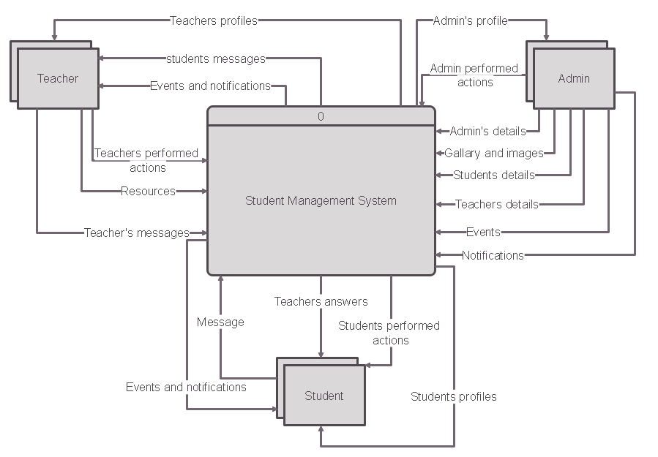

DFD LEVEL 1

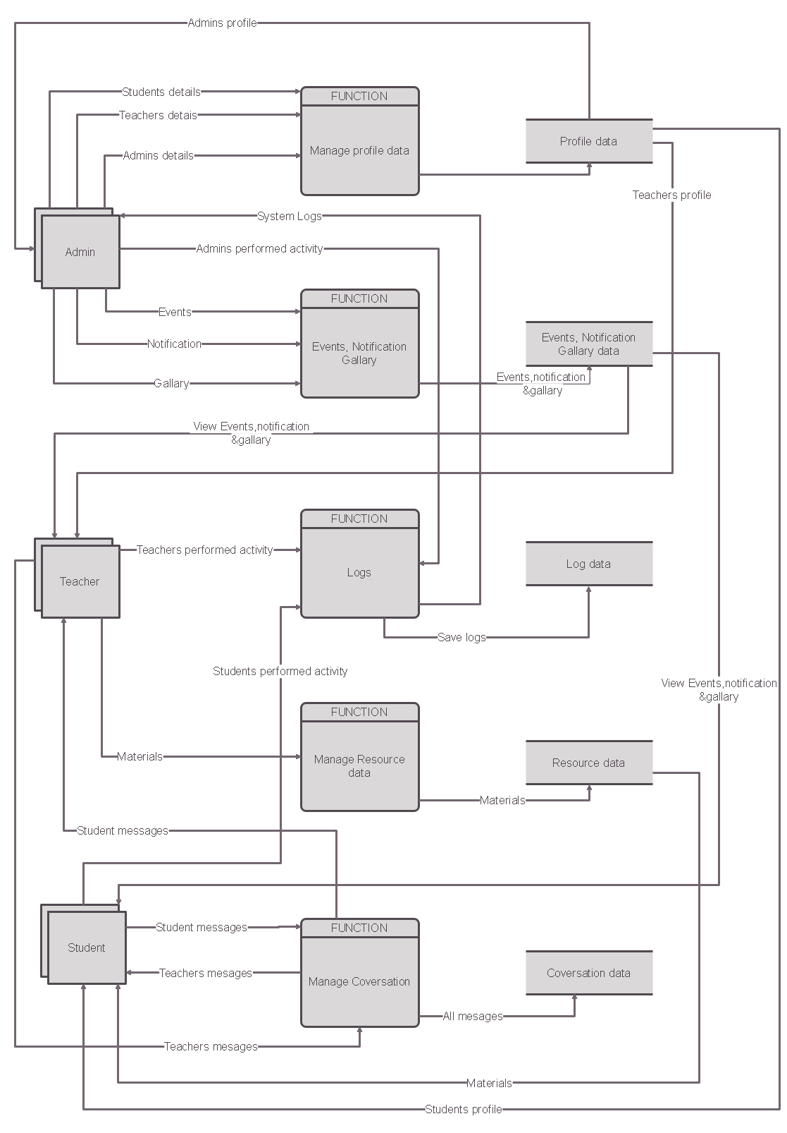

USECASE DIAGRAM

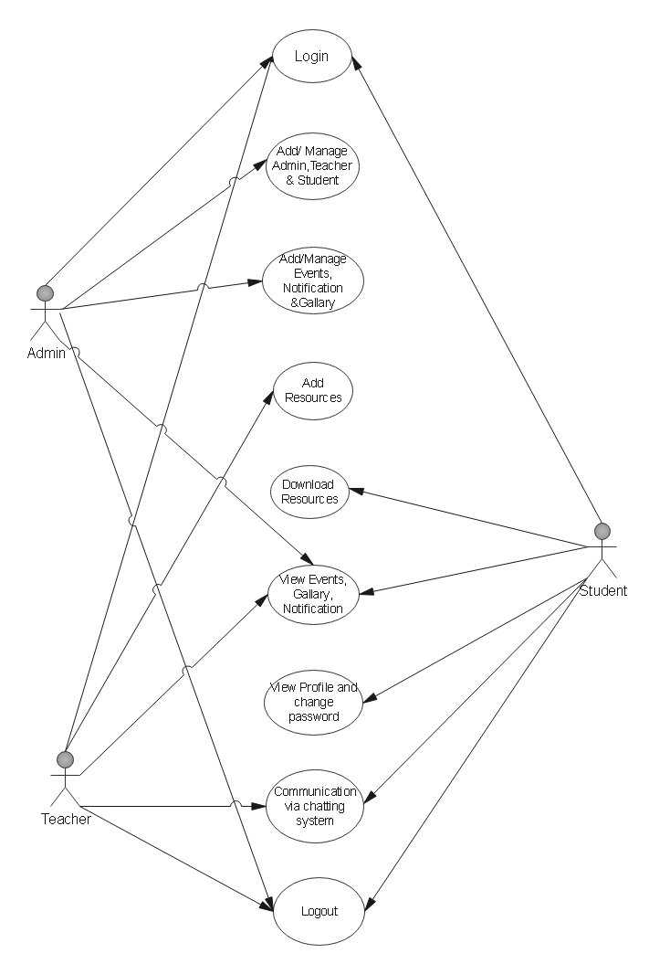

Admin’s Activity Diagram

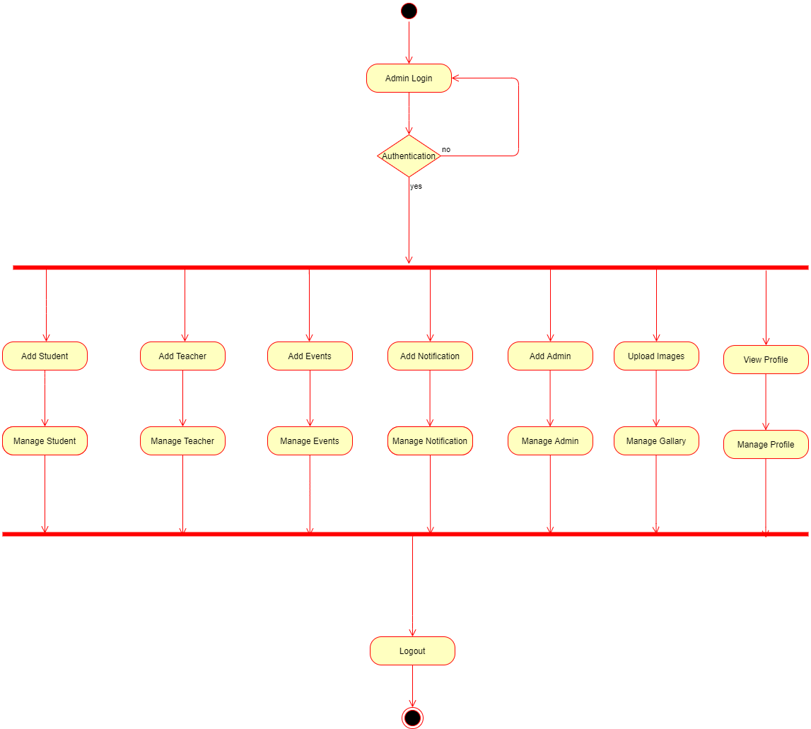

Teacher’s Activity Diagram

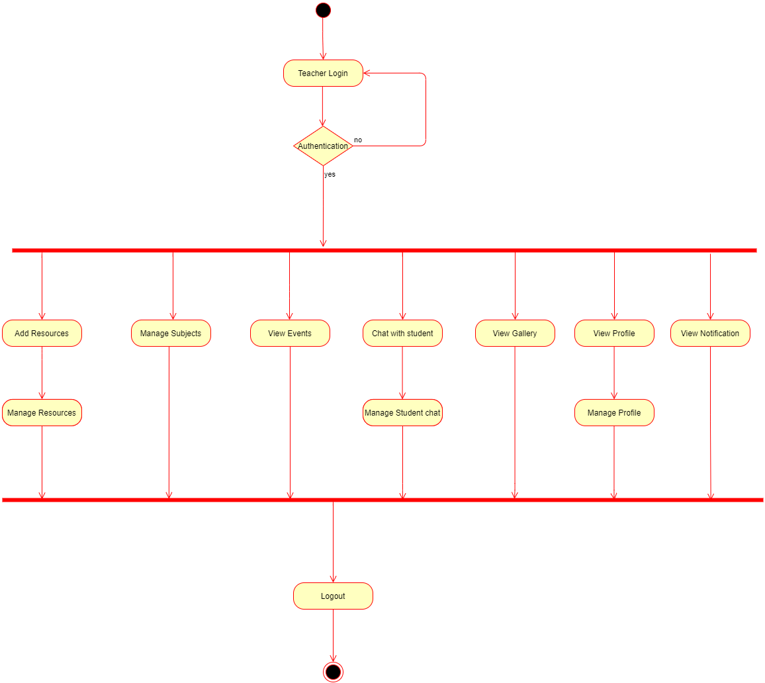

Student’s Activity Diagram

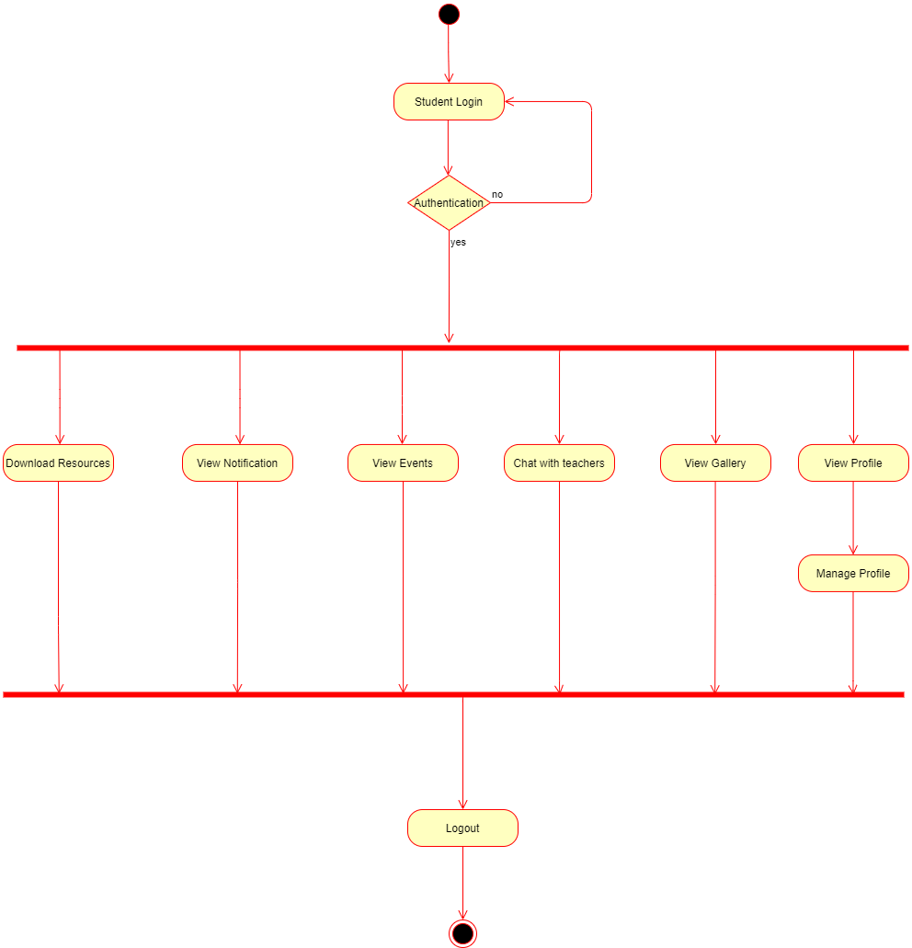

Entity Relationship Diagram

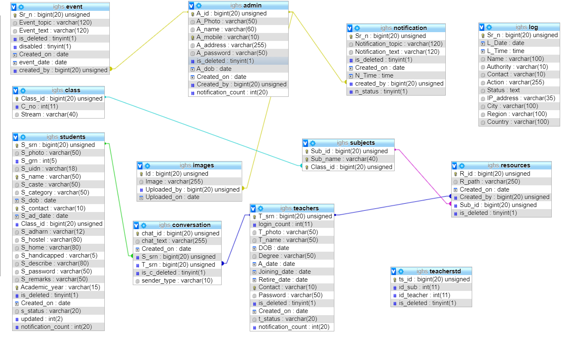

**System Snapshots**

* There are total 3 sections in our system .
* Admin Panel
* Teacher Panel
* Student Panel
* Admin Panel is most important part of our project and it consist of most featured to manage student's, teacher's and other admin's data.
* Teacher Panel enables teacher to send study material to students and receive message from student and send reply to those messages .And also teachers can see images, event information, And notifications uploaded by admin.
* Student Panel allows students to download study material from site uploaded by their subject teachers, Students can message teacher to solve their query. And also students can see images, event information, And notifications uploaded by admin.

**Admin Panel**

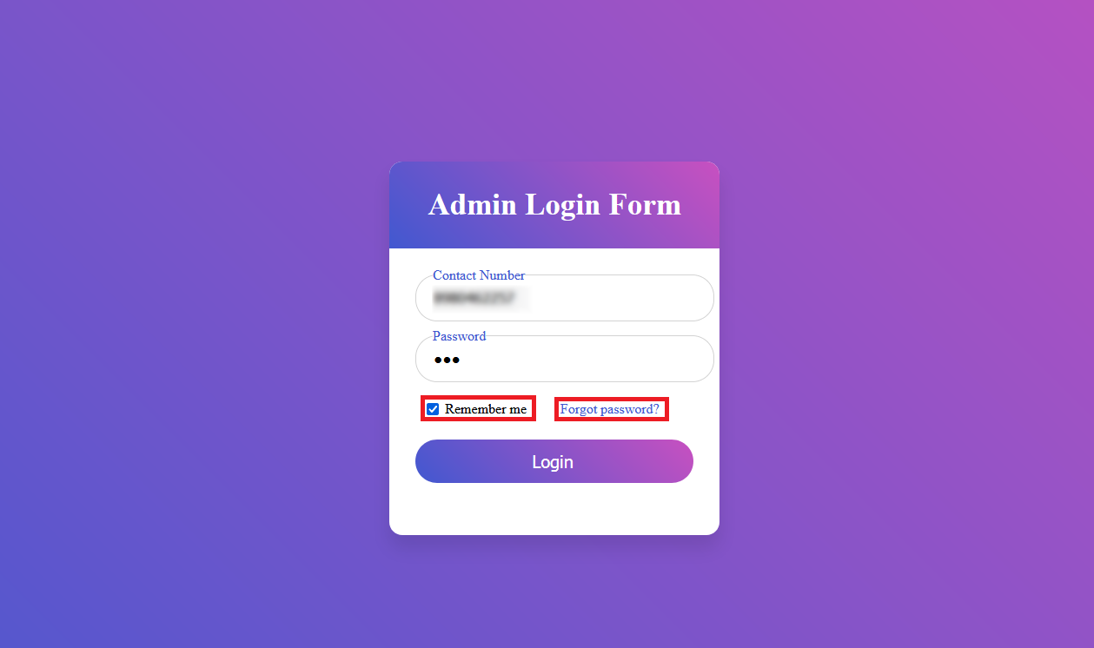

**Image- 1**

* This is the Login page for Admin.
* Admin will need to enter their registered mobile number and their password in order to login to their account.
* They can choose to save their details by selecting "Remember me " checkbox and if they want to delete their details they can deselect checkbox next time they login
* If admin forgot his/her account password they can click on "Forgot password" and receive an OTP (One Time Password), to the mobile number registered in their account and reset the password.

1. Step after clicking on "Forgot Password". Enter mobile number in the given text box and click on "Get OTP" to receive OTP.

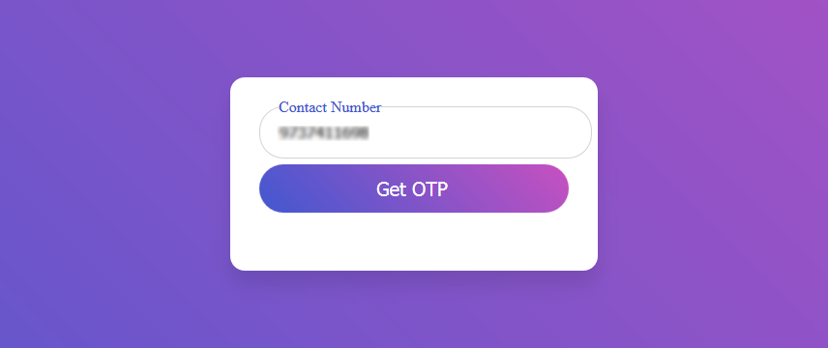

**Image-1.1**

1. User will receive an OTP on the mobile number , enter that code in next page as below. And click on Verify to confirm code .

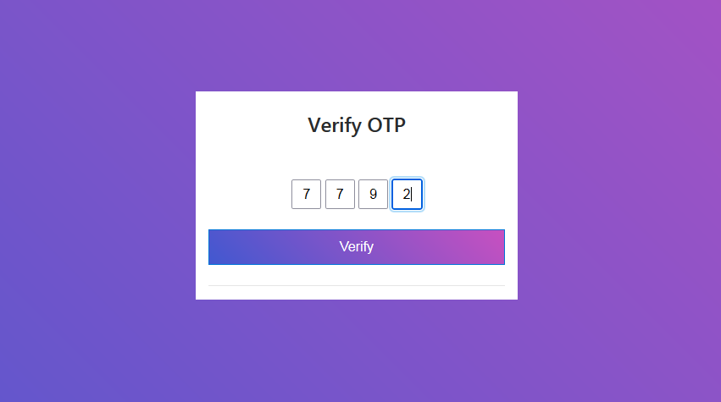

**Image-1.2**

1. If OTP code is correct User can reset password in next page . And Submit to login into their account.

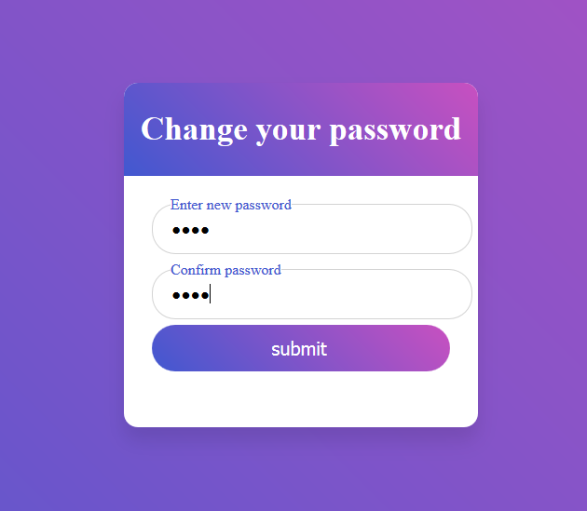**Image-1.3**

**Admin Dashboard**

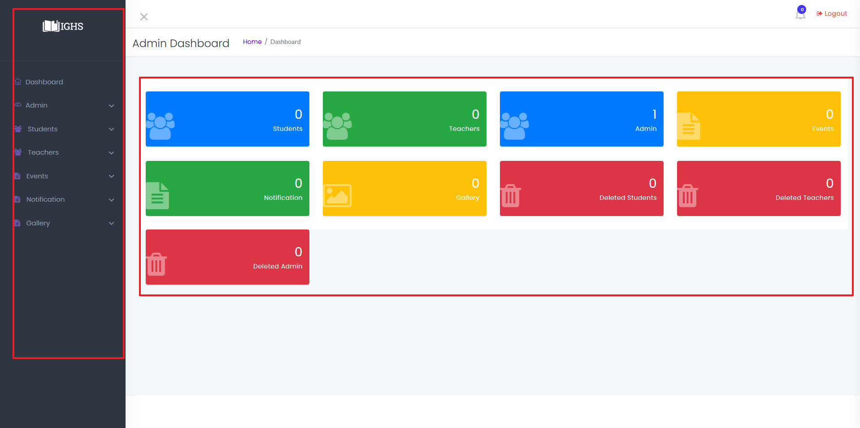

**Image-2**

* This is Admin Dashboard where Admin can access all features to manage every data .
  1. Admin can see how many students, Teachers , Admins, Events , Notifications, Images in Gallery, Deleted students ,Deleted teachers ,Deleted admins are in system.
  2. On left side of the screen admin can use shortcuts to easily navigate through system.

**Admin : Manage Student Data**

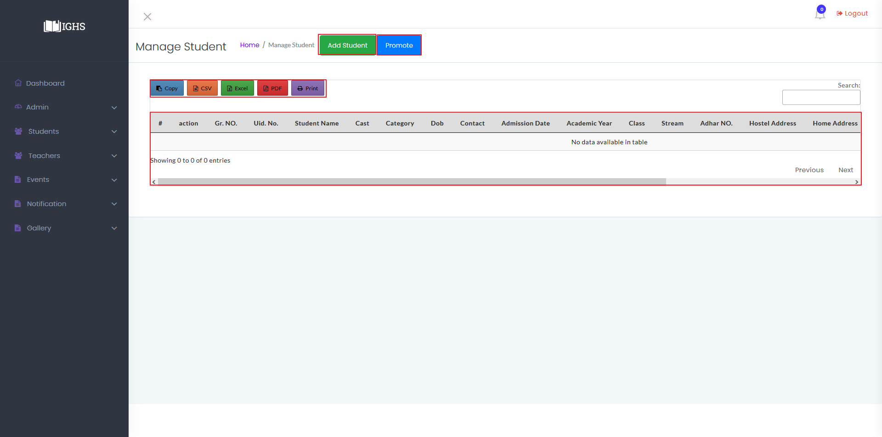  
**Image-2.1**

* Admin can access this page ( Manage Student Window) by clicking on "Students ", on image number 2.
* In image 2.1 the table is empty because there are no data in system yet, To add a student data click on "Add Student" highlighted with red box in image 2.1.

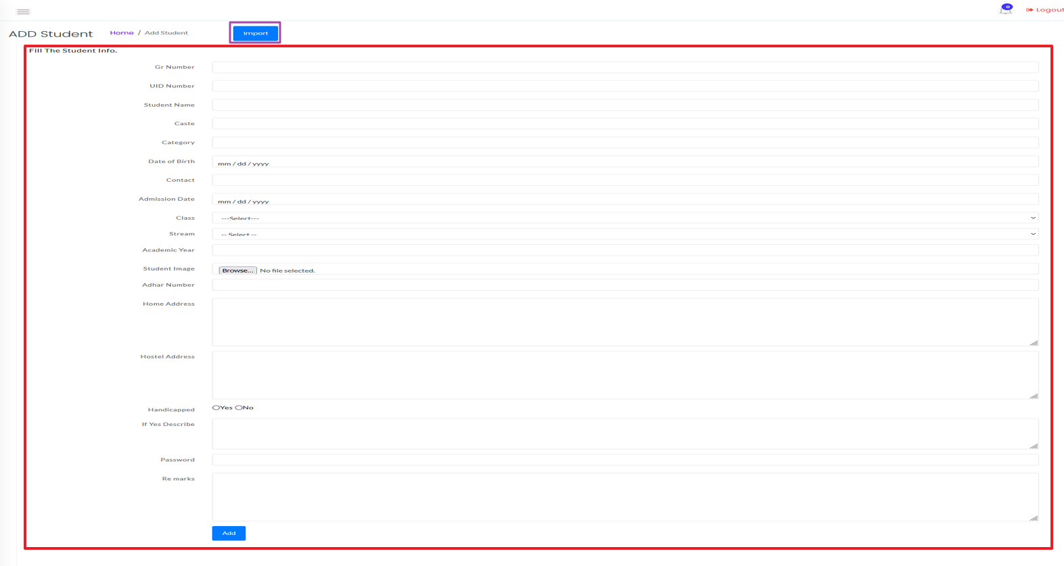

**Image-2.2**

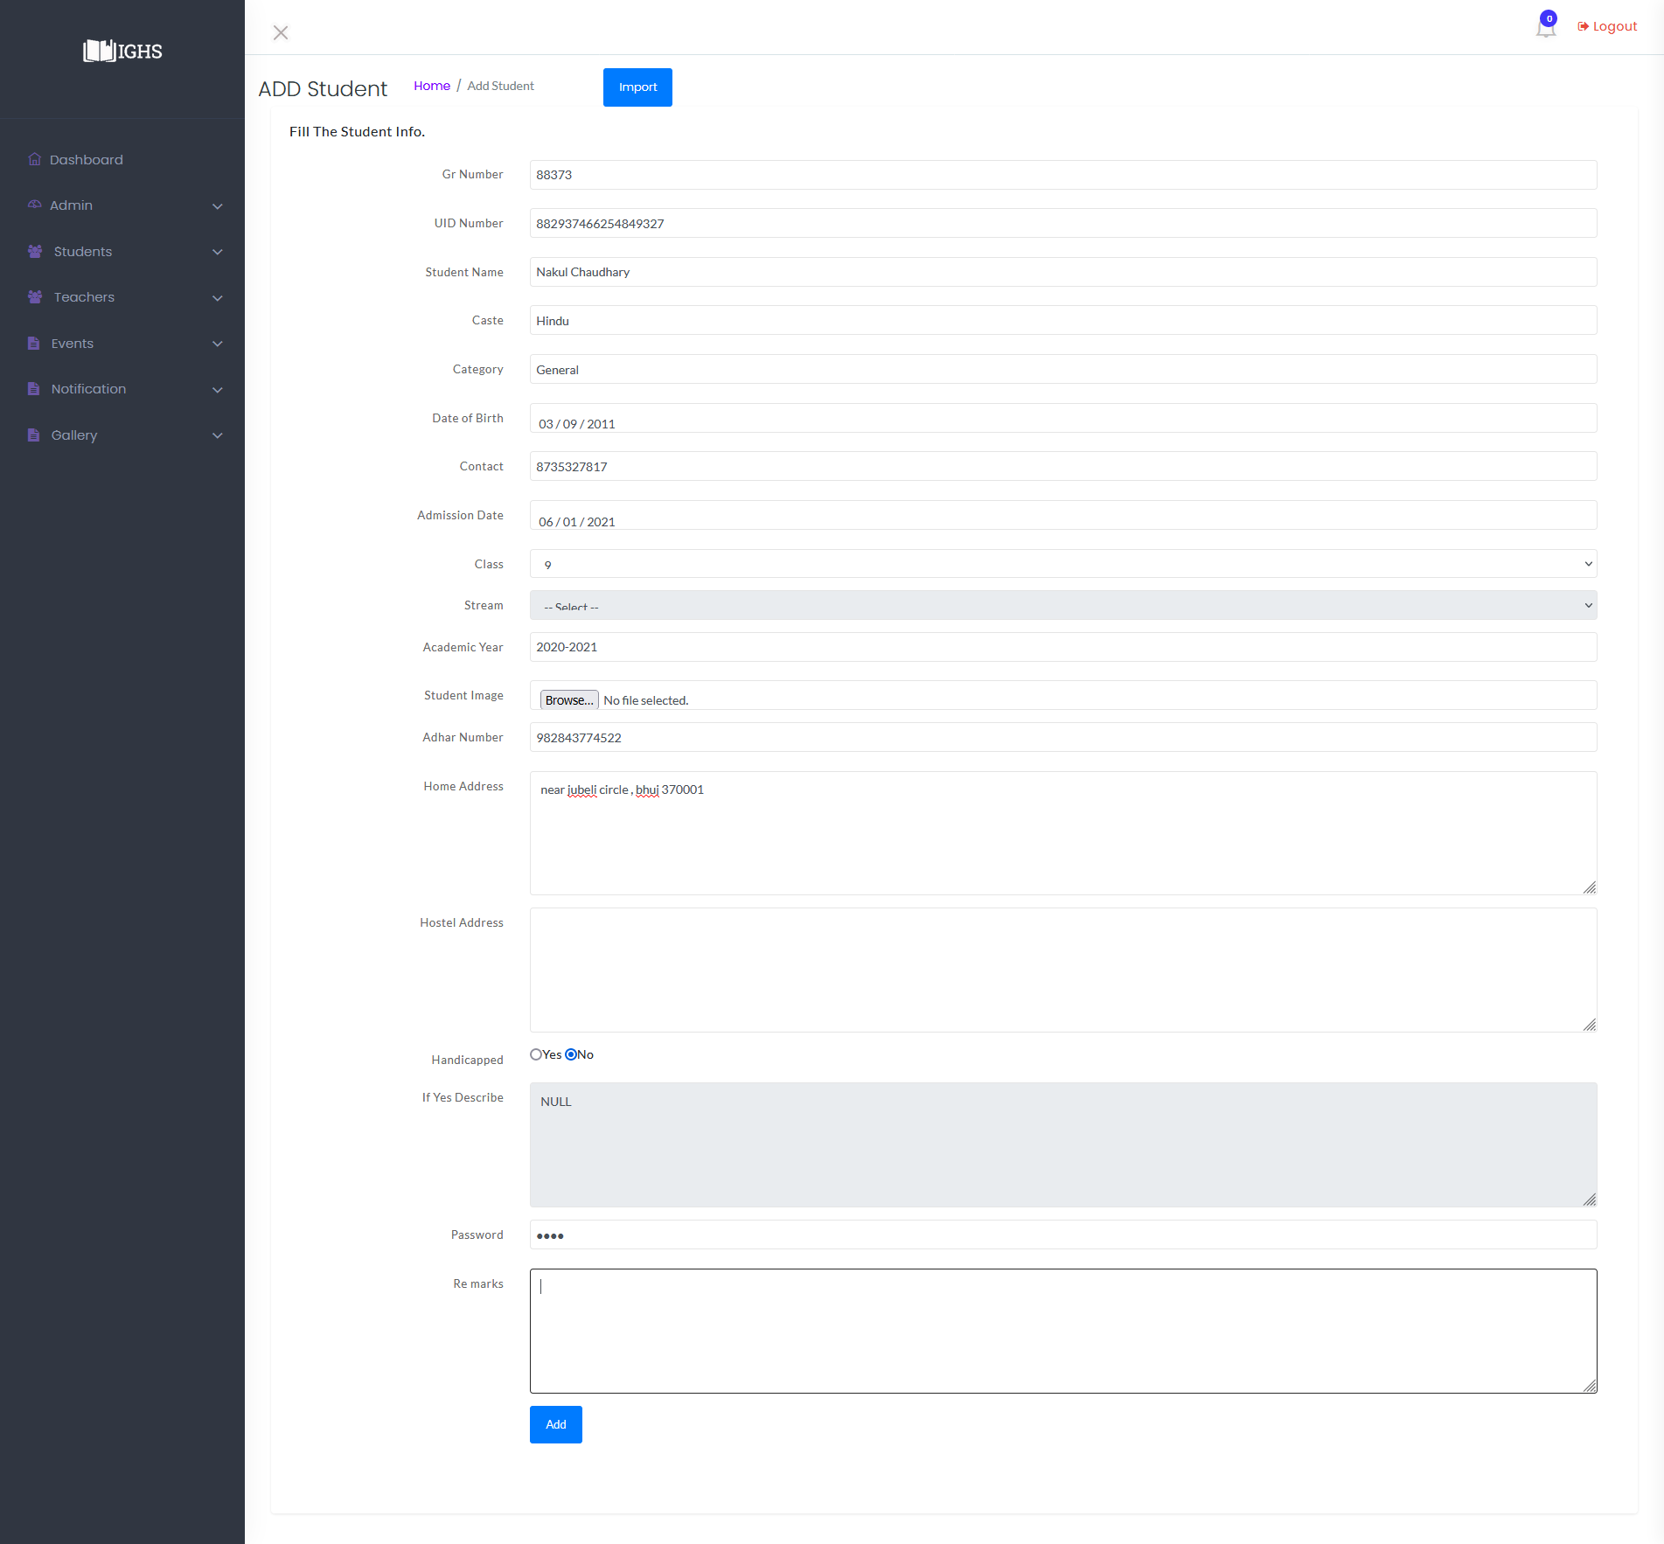

**Image-2.2.1**

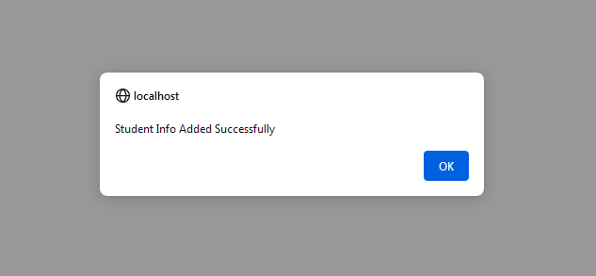

**Image-2.2.2**

* Admin can Enter a single Student at a time by filling up the form highlighted with red box, and click on "Add" button available at end of form .
* After filling the form it will look like image-2.2.1, And After submitting it if the data is proper then data will be stored and generate an Success alert shown in image-2.2.2.
* If data is not valid then it won't let admin to submit form.
* To Add multiple student data at a time then click on "Import" button highlighted with purple box in image-2.2.

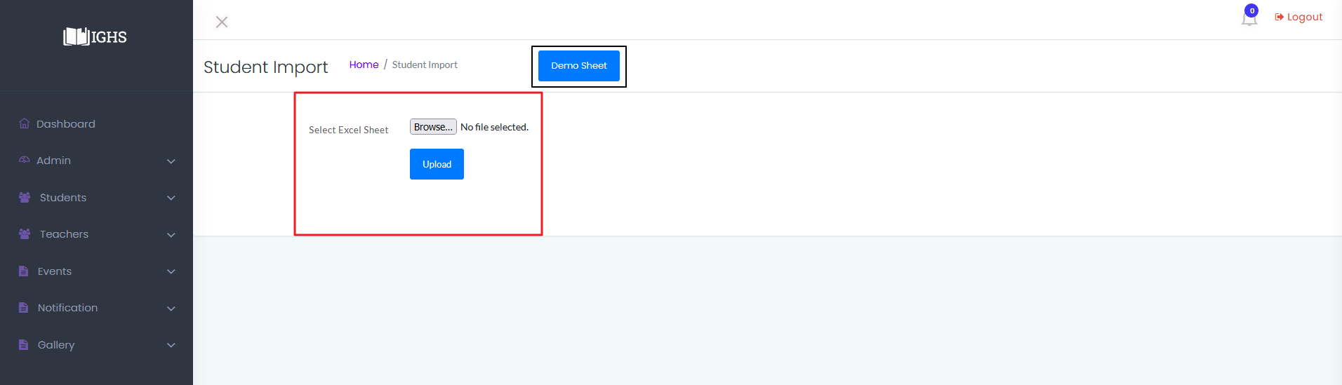

**Image-2.3**

* Then click on "Demo Sheet" highlighted with black box in image-2.3 to download an empty sheet with column names which will look like as Image-2.3.1 as shown below.

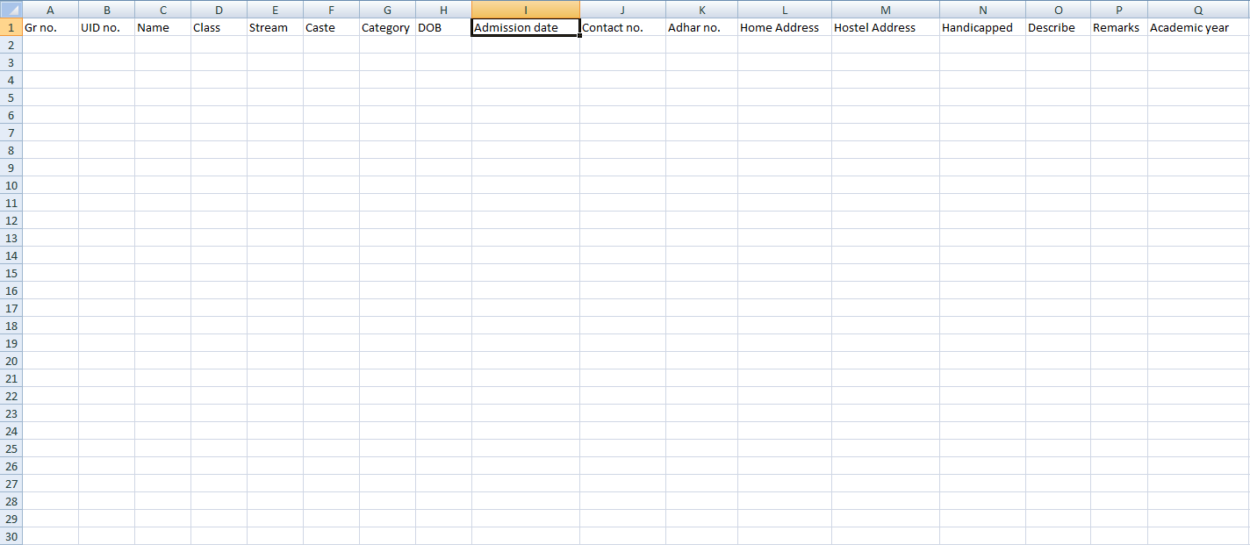

**Image-2.3.1**

* Admin will need to set format column B and column K to TEXT. And format column H and column I to custom date "yyyy-mm-dd".

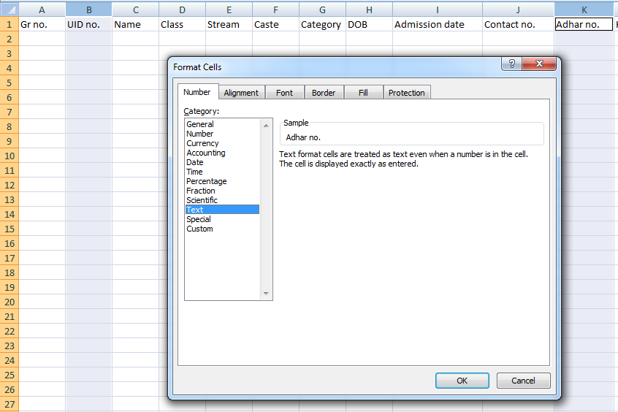

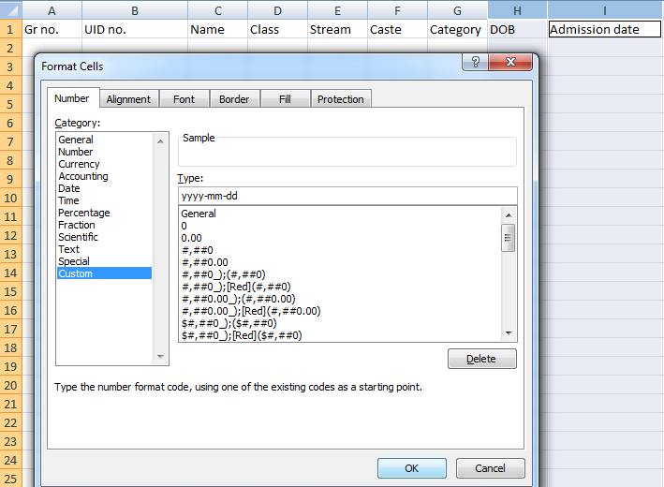

**Image-2.3.2 & Image-2.3.3**

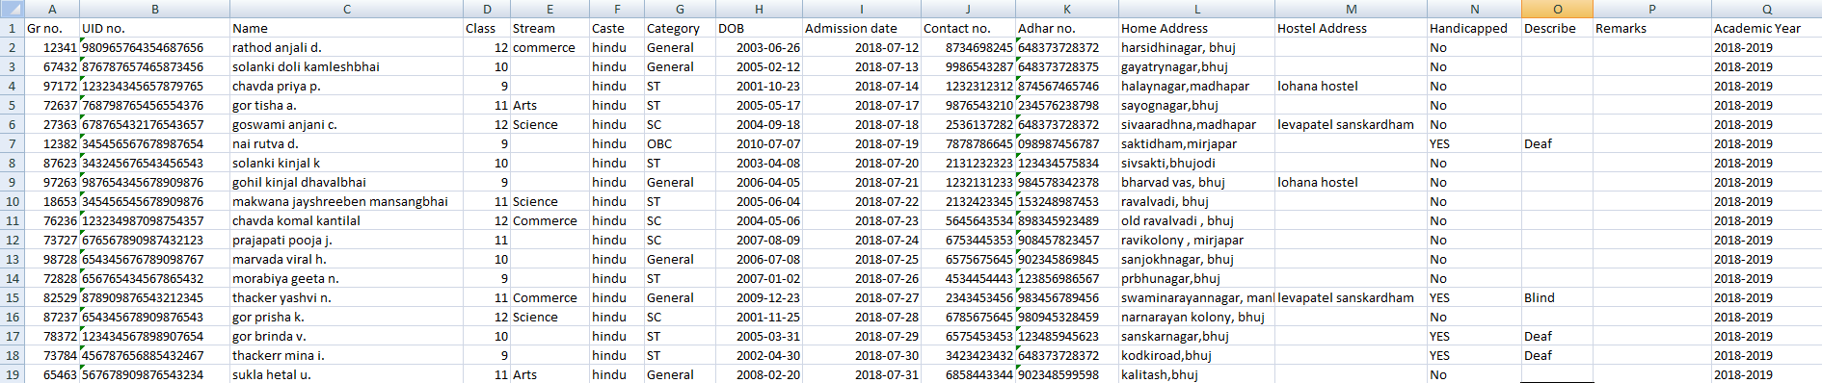

**Image-2.3.2**

* After filling up the data

**Teacher Panel**

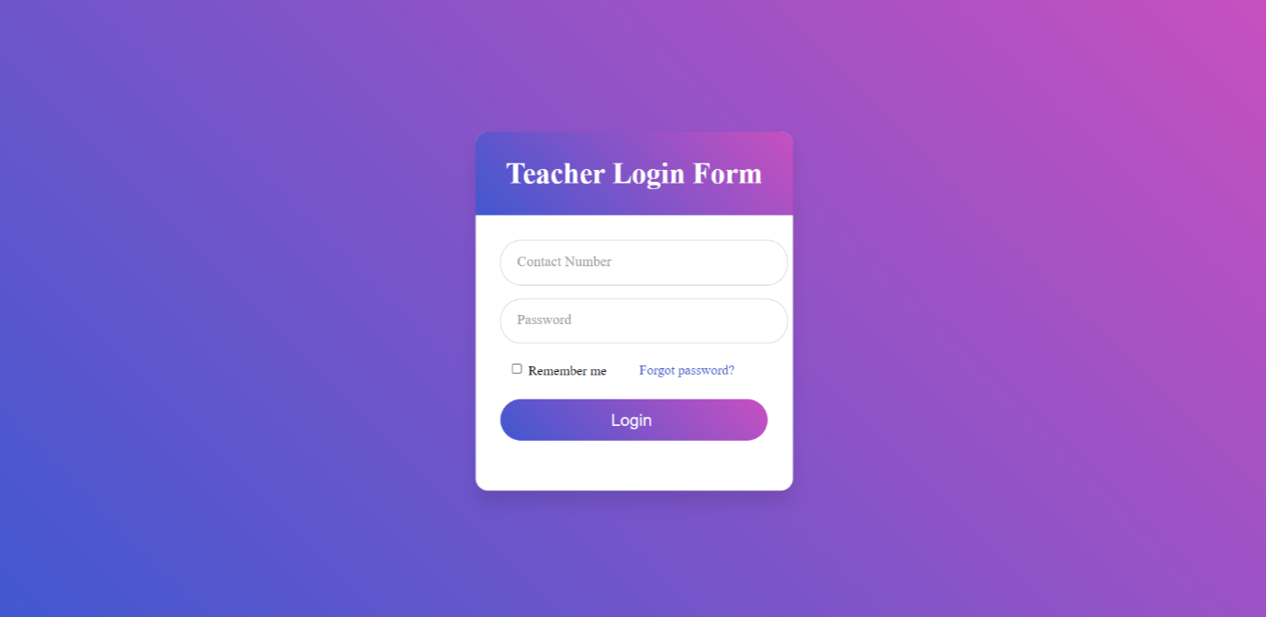

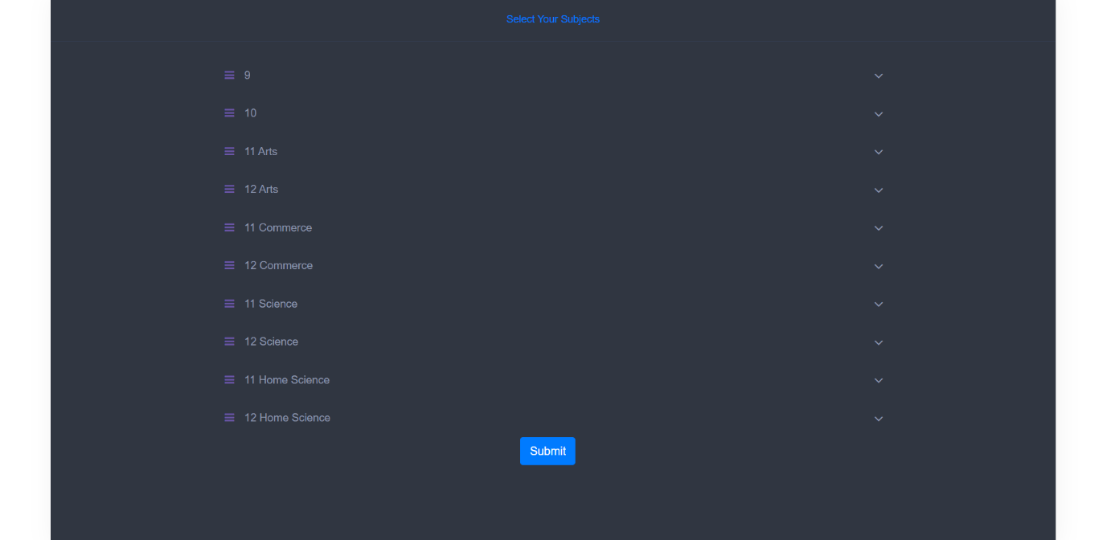

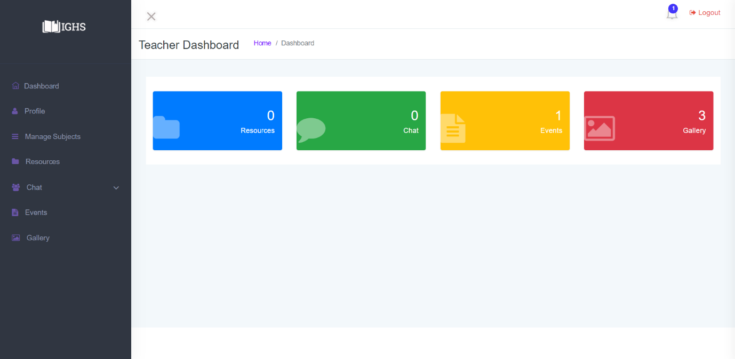

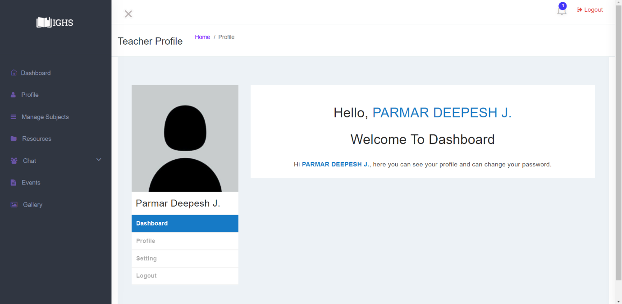

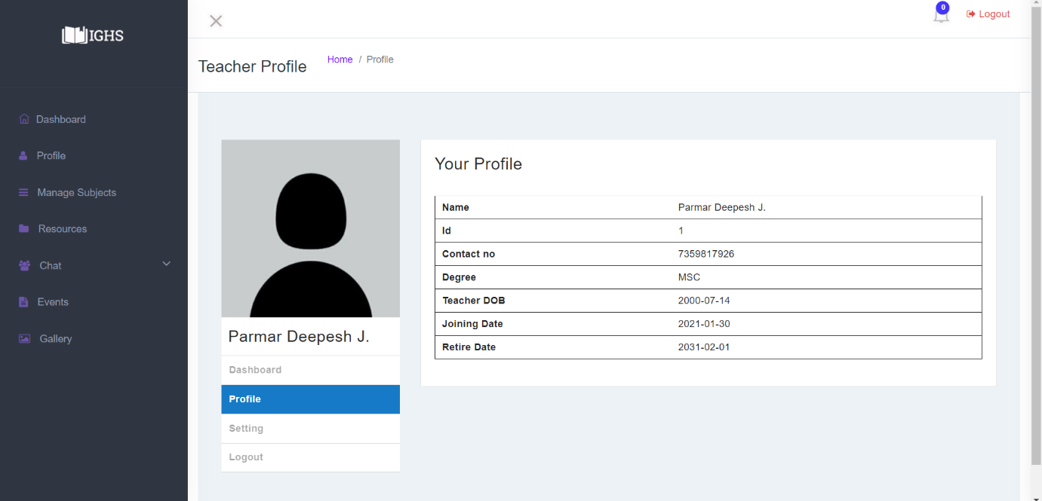

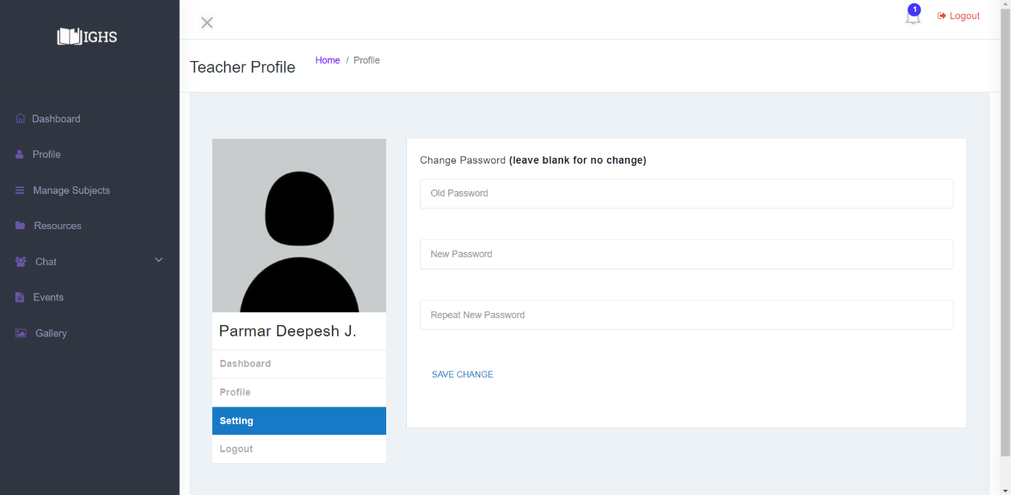

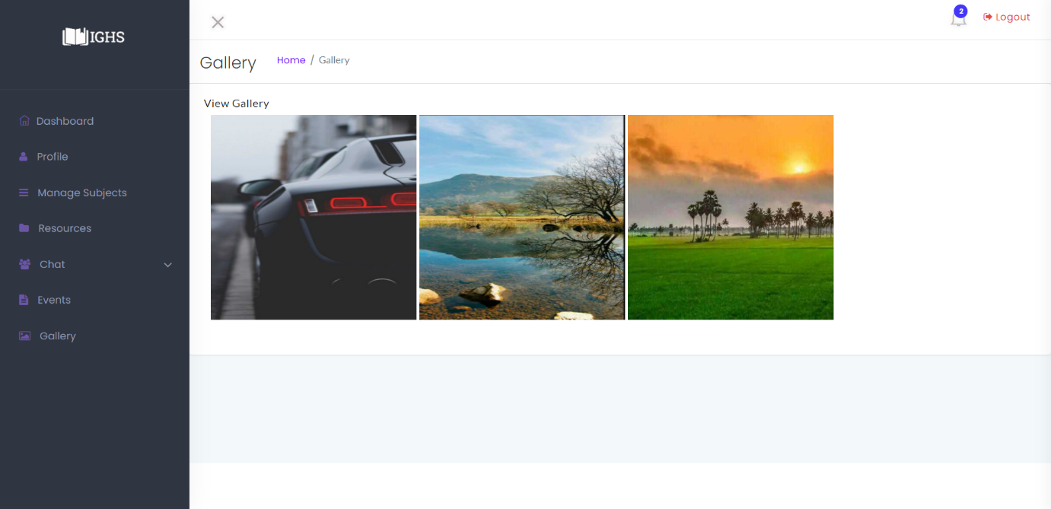

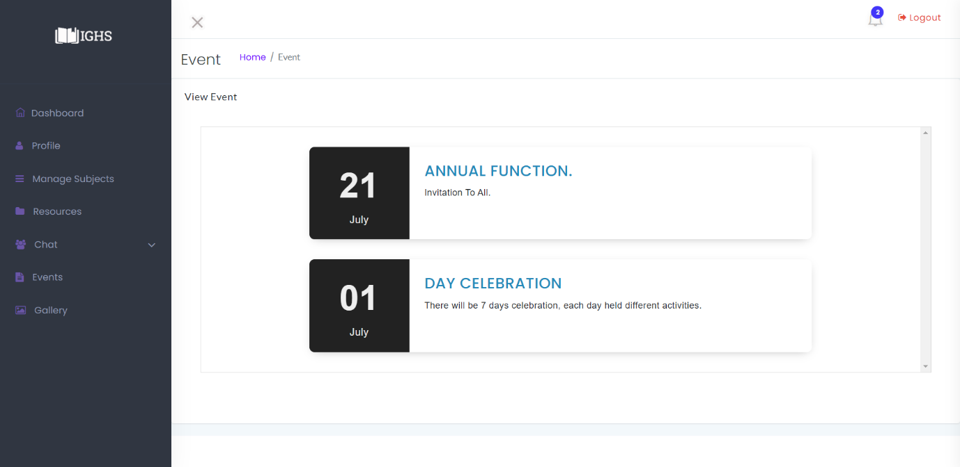

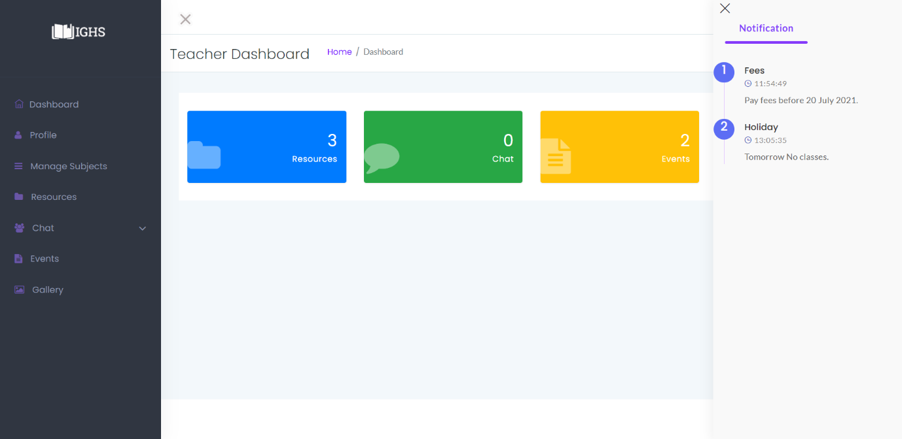

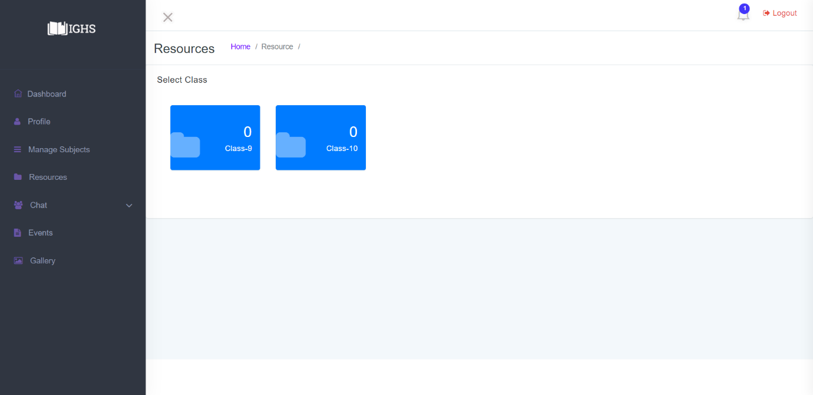

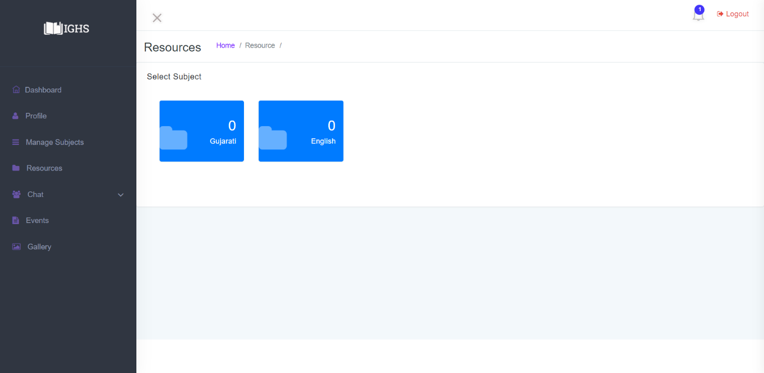

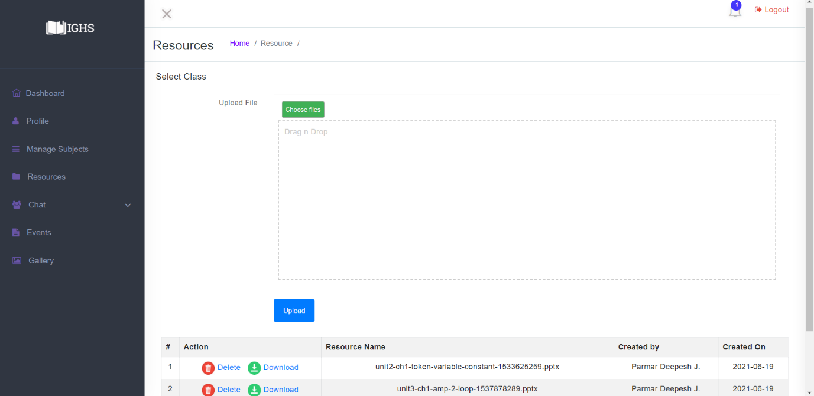

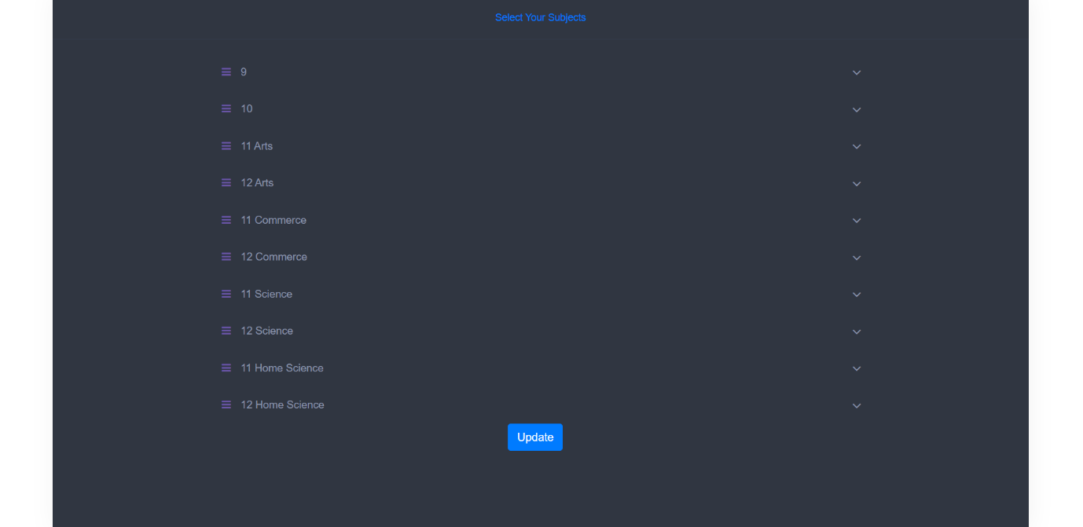

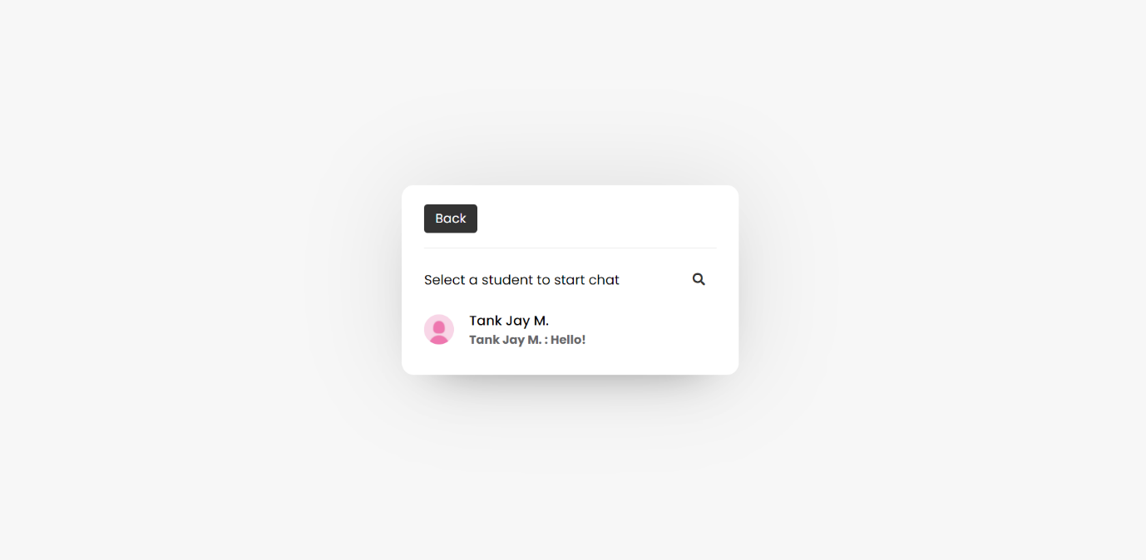

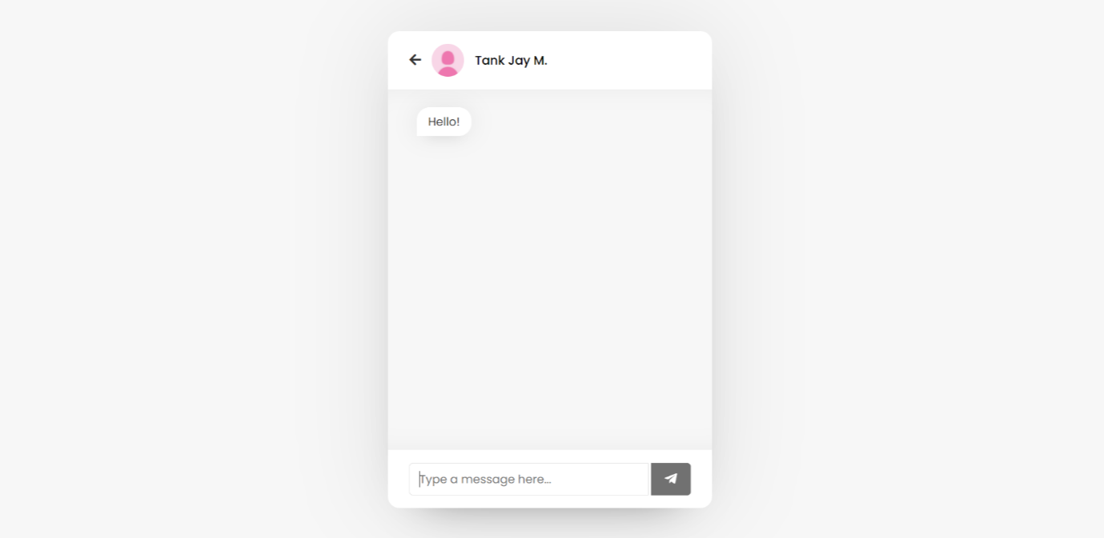

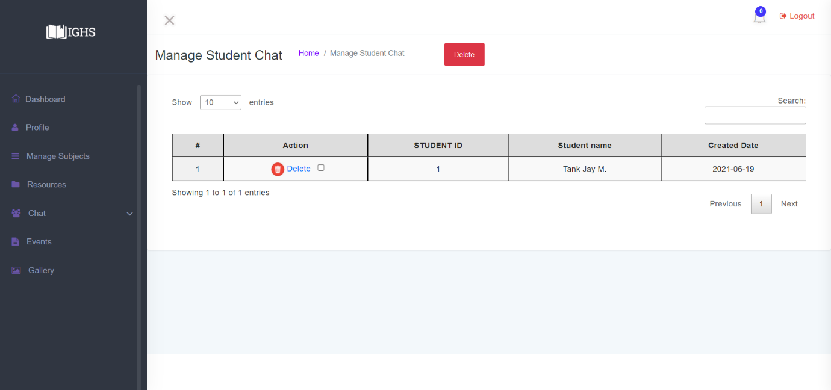

Student

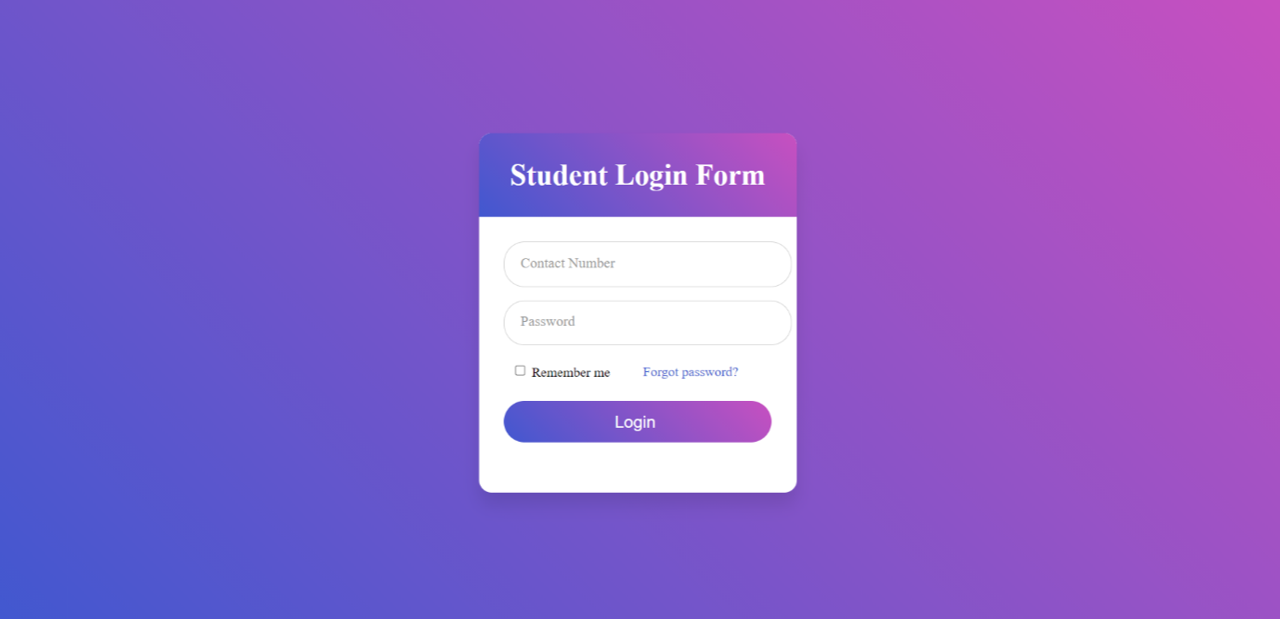

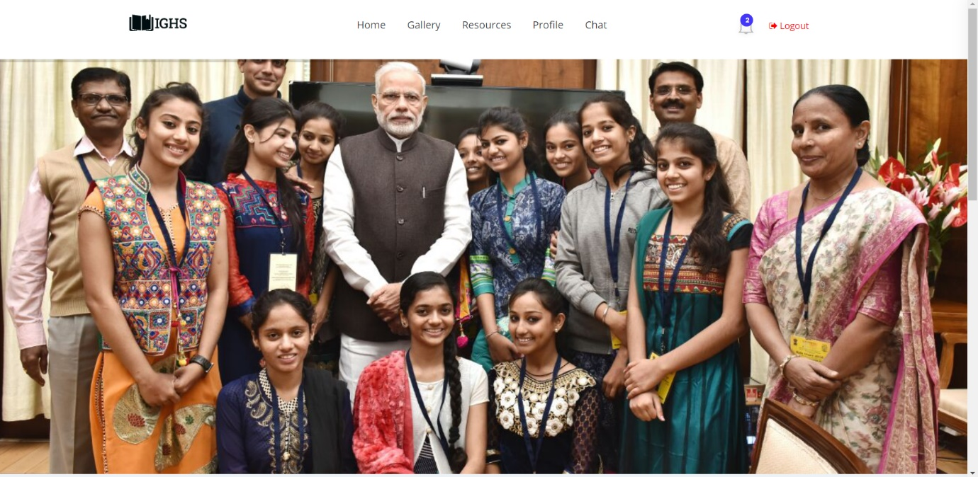

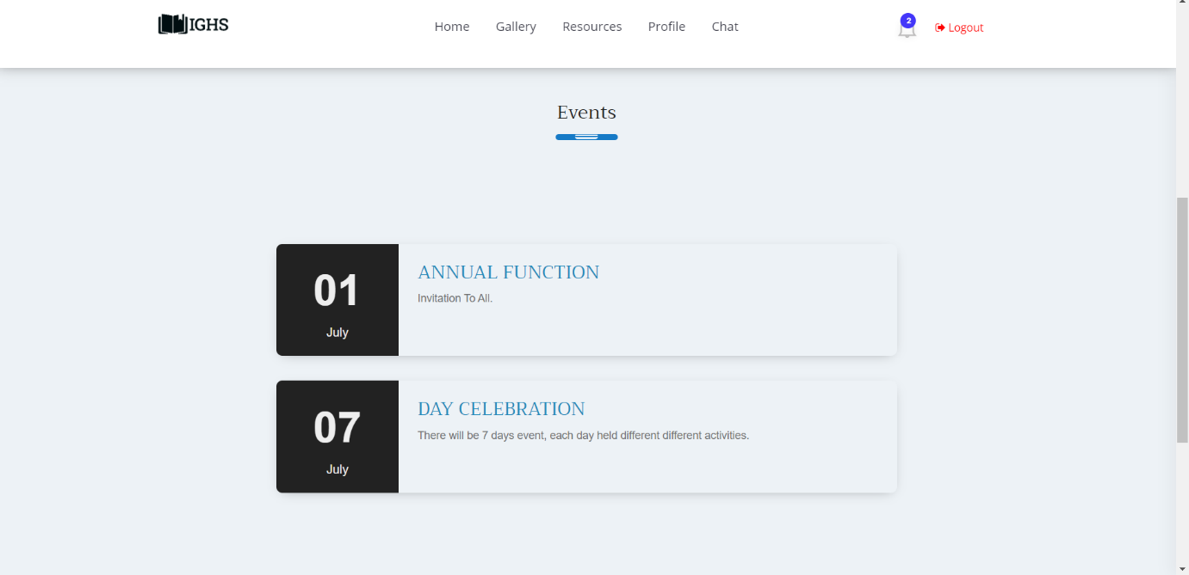

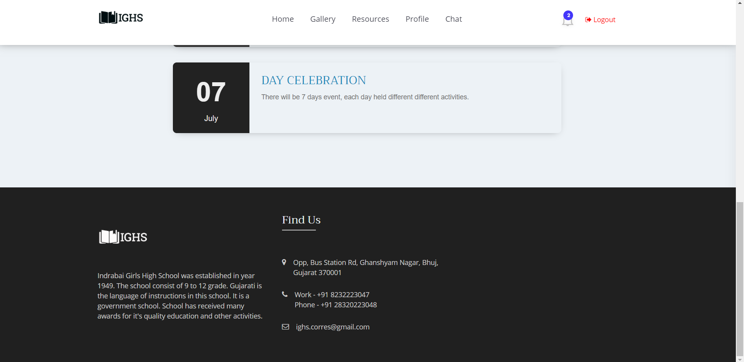

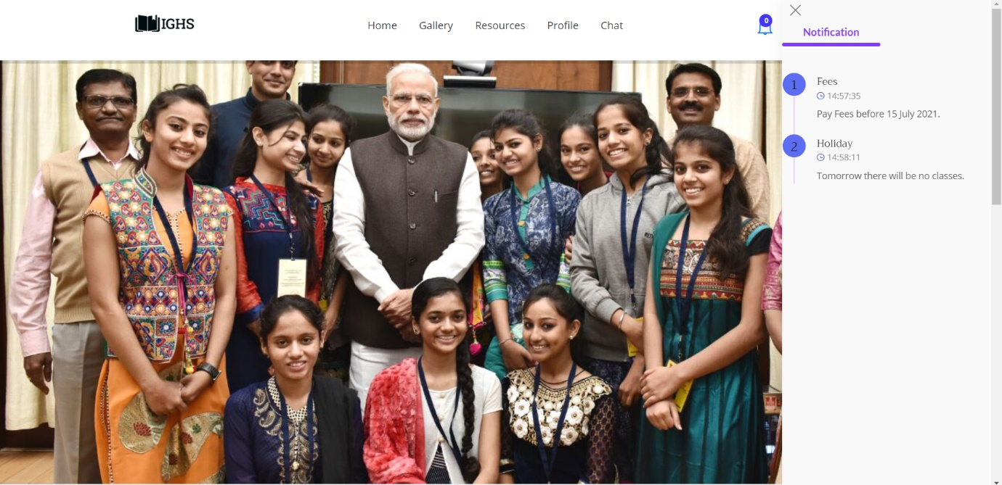

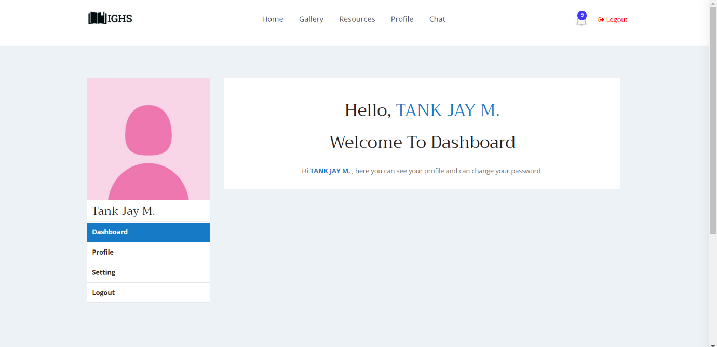

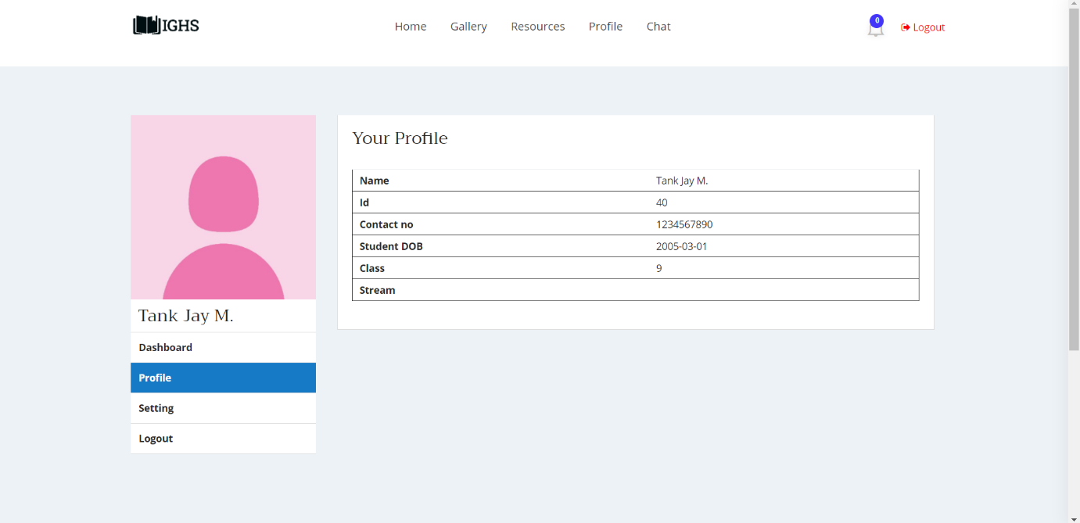

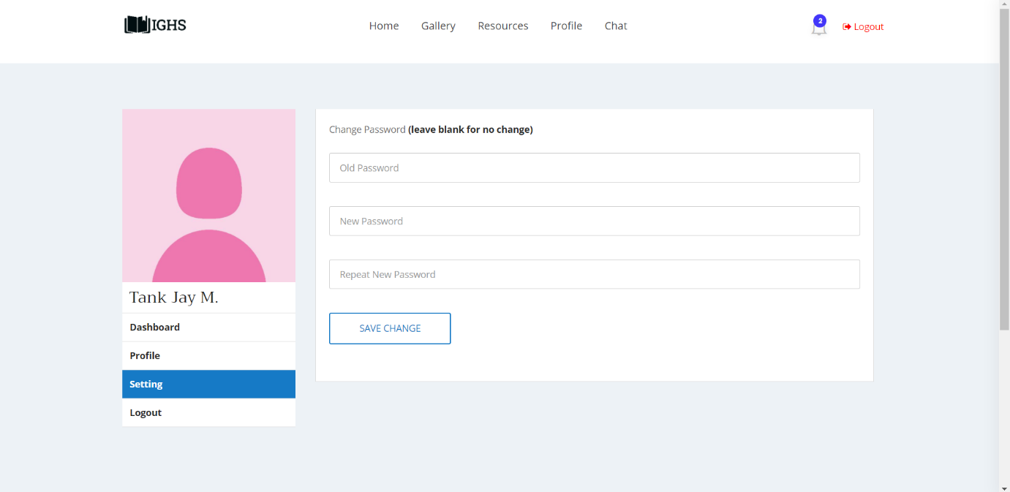

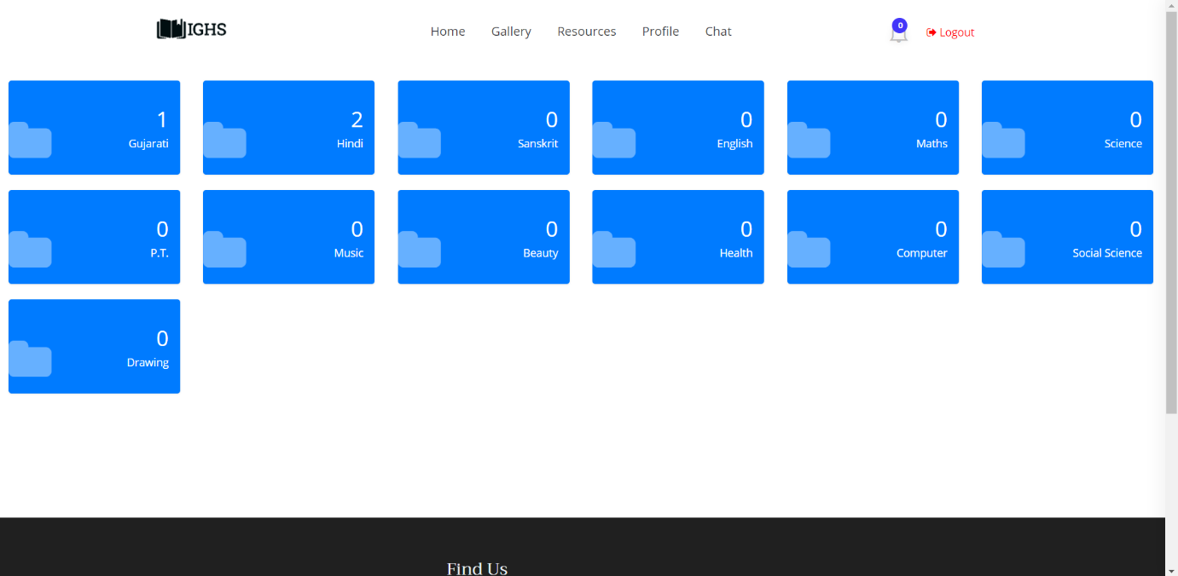

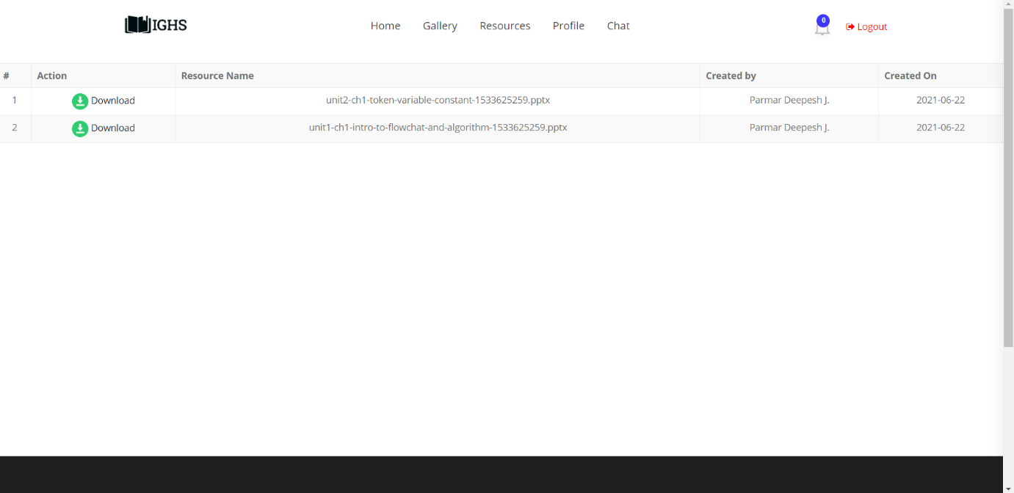

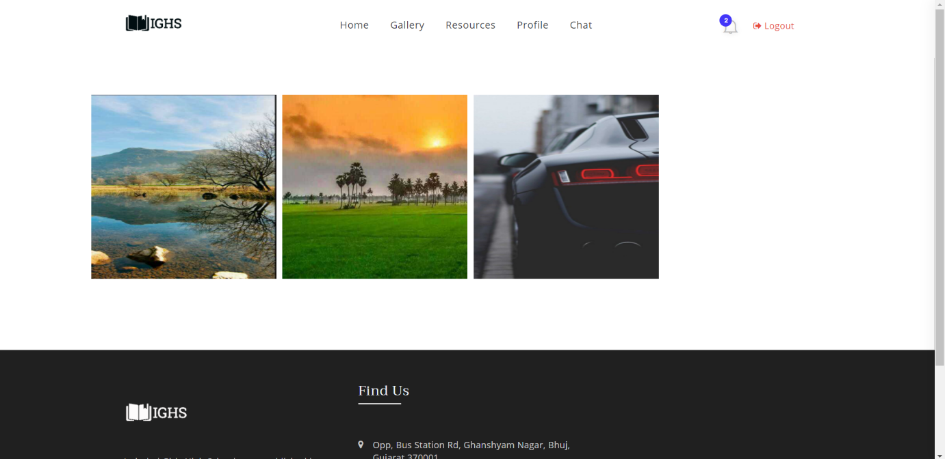

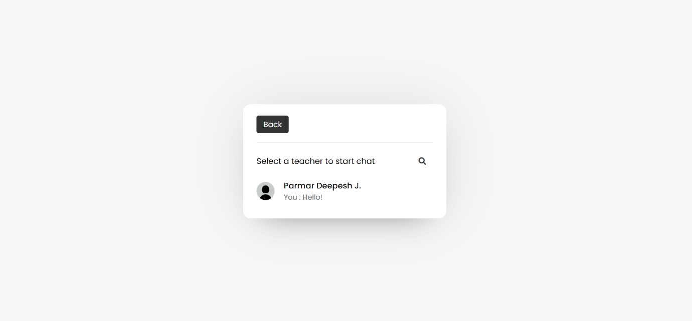

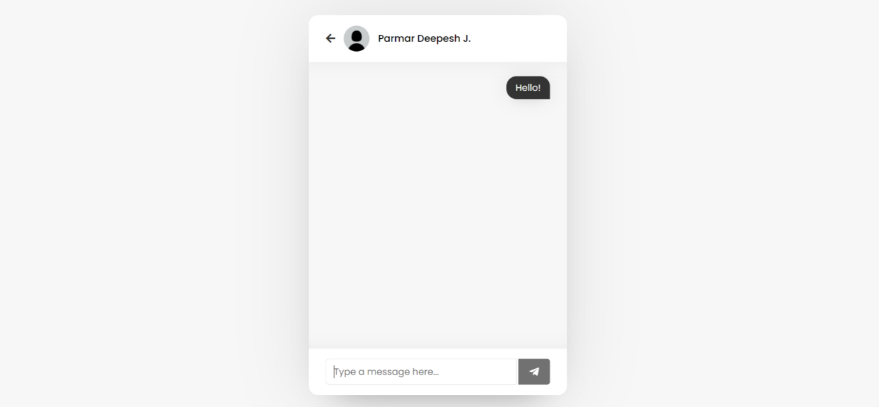

**admin**

|  |  |  |  |
| --- | --- | --- | --- |
| **Column** | **Type** | **Null** | **Default** |
| A_id *(Primary)* | bigint(20) | No |  |
| A_Photo | varchar(50) | Yes | *NULL* |
| A_name | varchar(60) | No |  |
| A_mobile | varchar(10) | No |  |
| A_address | varchar(255) | No |  |
| A_password | varchar(50) | No |  |
| is_deleted | tinyint(1) | No |  |
| A_dob | date | No |  |
| Created_on | date | No | curdate() |
| Created_by | bigint(20) | No |  |
| notification_count | int(20) | No |  |

**Class**

|  |  |  |
| --- | --- | --- |
| **Column** | **Type** | **Null** |
| Class_id *(Primary)* | bigint(20) | No |
| C_no | int(11) | No |
| Stream | varchar(40) | No |

**conversation**

|  |  |  |  |  |
| --- | --- | --- | --- | --- |
| **Column** | **Type** | **Null** | **Default** | **Links to** |
| chat_id | bigint(20) | No |  |  |
| chat_text | varchar(255) | No |  |  |
| Created_on | date | No | curdate() |  |
| S_srn | bigint(20) | No |  | students ->S_srn |
| T_srn | bigint(20) | No |  | teachers ->T_srn |
| is_c_deleted | tinyint(1) | No |  |  |
| sender_type | varchar(10) | No |  |  |

**event**

|  |  |  |  |  |
| --- | --- | --- | --- | --- |
| **Column** | **Type** | **Null** | **Default** | **Links to** |
| Sr_n *(Primary)* | bigint(20) | No |  |  |
| Event_topic | varchar(120) | No |  |  |
| Event_text | varchar(120) | No |  |  |
| is_deleted | tinyint(1) | No |  |  |
| disabled | tinyint(1) | No | 0 |  |
| Created_on | date | No | curdate() |  |
| event_date | date | No |  |  |
| created_by | bigint(20) | No |  | admin ->A_id |

**images**

|  |  |  |  |  |
| --- | --- | --- | --- | --- |
| **Column** | **Type** | **Null** | **Default** | **Links to** |
| Id *(Primary)* | bigint(20) | No |  |  |
| Image | varchar(255) | No |  |  |
| Uploaded_by | bigint(20) | No |  | admin ->A_id |
| Uploaded_on | date | No | curdate() |  |

**log**

|  |  |  |  |
| --- | --- | --- | --- |
| **Column** | **Type** | **Null** | **Default** |
| Sr_n *(Primary)* | bigint(20) | No |  |
| L_Date | date | No | curdate() |
| L_Time | time | No | current_timestamp() |
| Name | varchar(100) | No |  |
| Authority | varchar(10) | No |  |
| Contact | varchar(10) | No |  |
| Action | varchar(255) | No |  |
| Status | text | No |  |
| IP_address | varchar(35) | No |  |
| City | varchar(100) | No |  |
| Region | varchar(100) | No |  |
| Country | varchar(100) | No |  |

**notification**

|  |  |  |  |  |
| --- | --- | --- | --- | --- |
| **Column** | **Type** | **Null** | **Default** | **Links to** |
| Sr_n *(Primary)* | bigint(20) | No |  |  |
| Notification_topic | varchar(120) | No |  |  |
| Notification_text | varchar(120) | No |  |  |
| is_deleted | tinyint(1) | No |  |  |
| Created_on | date | No | curdate() |  |
| N_Time | time | No | current_timestamp() |  |
| created_by | bigint(20) | No |  | admin ->A_id |
| n_status | tinyint(1) | No |  |  |

**resources**

|  |  |  |  |  |
| --- | --- | --- | --- | --- |
| **Column** | **Type** | **Null** | **Default** | **Links to** |
| R_id *(Primary)* | bigint(20) | No |  |  |
| R_path | varchar(250) | No |  |  |
| Created_on | date | No | curdate() |  |
| Created_by | bigint(20) | No |  | teachers ->T_srn |
| Sub_id | bigint(20) | No |  | subjects ->Sub_id |
| is_deleted | tinyint(1) | No | 0 |  |

**students**

|  |  |  |  |
| --- | --- | --- | --- |
| **Column** | **Type** | **Null** | **Default** |
| S_srn *(Primary)* | bigint(20) | No |  |
| S_photo | varchar(50) | Yes | *NULL* |
| S_grn | int(5) | No |  |
| S_uidn | varchar(18) | No |  |
| S_name | varchar(50) | No |  |
| S_caste | varchar(50) | No |  |
| S_category | varchar(50) | No |  |
| S_dob | date | No |  |
| S_contact | varchar(10) | No |  |
| S_ad_date | date | No |  |
| Class_id | bigint(20) | No |  |
| S_adharn | varchar(12) | No |  |
| S_hostel | varchar(80) | No |  |
| S_home | varchar(80) | No |  |
| S_handicapped | varchar(5) | No |  |
| S_describe | varchar(80) | No |  |
| S_password | varchar(50) | No |  |
| S_remarks | varchar(50) | No |  |
| Academic_year | varchar(15) | No |  |
| is_deleted | tinyint(1) | No |  |
| Created_on | date | No | curdate() |
| s_status | varchar(20) | No |  |
| updated | int(2) | No |  |
| notification_count | int(20) | No |  |

**subjects**

|  |  |  |  |
| --- | --- | --- | --- |
| **Column** | **Type** | **Null** | **Links to** |
| Sub_id *(Primary)* | bigint(20) | No |  |
| Sub_name | varchar(40) | No |  |
| Class_id | bigint(20) | No | class ->Class_id |

**teachers**

|  |  |  |  |
| --- | --- | --- | --- |
| **Column** | **Type** | **Null** | **Default** |
| T_srn *(Primary)* | bigint(20) | No |  |
| login_count | int(11) | No |  |
| T_photo | varchar(50) | Yes | *NULL* |
| T_name | varchar(50) | No |  |
| DOB | date | No |  |
| Degree | varchar(50) | No |  |
| A_date | date | No |  |
| Joining_date | date | No |  |
| Retire_date | date | No |  |
| Contact | varchar(10) | No |  |
| Password | varchar(50) | No |  |
| is_deleted | tinyint(1) | No |  |
| Created_on | date | No | curdate() |
| t_status | varchar(20) | No |  |
| notification_count | int(20) | No |  |

**teacherstd**

|  |  |  |
| --- | --- | --- |
| **Column** | **Type** | **Null** |
| ts_id *(Primary)* | bigint(20) | No |
| id_sub | int(11) | No |
| id_teacher | int(11) | No |
| is_deleted | tinyint(1) | No |